LINK JOURNAL

<https://journal.admi.or.id/index.php/IJME/article/view/1777>

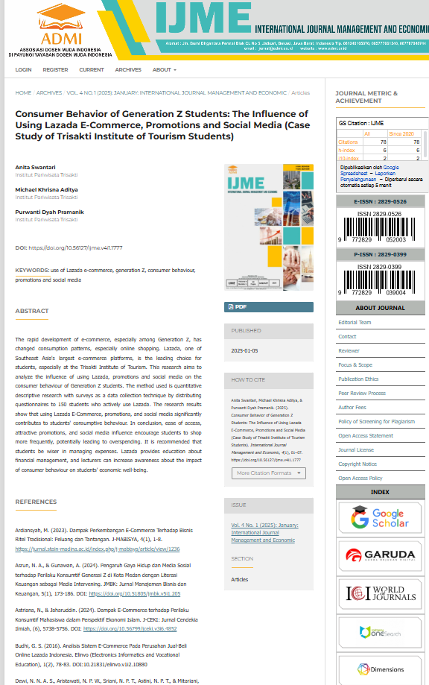

Daftar Isi, Team Editor

